**Name : Tanaka Trish**

**Surname : Nyamandi**

**Project Title : Dewure A level Digital**

**library system**

**Centre Number : 060084**

**Candidate number :**

**Duration : 2023 – 2024**

Table of Contents

Section A 6

Selection, Investigation and Analysis 6

Introduction 7

Background Information 7

Statement of problem 7

Problem definition 7

Investigation of the current system 7

Research instruments 8

1. Observations 8

2. Interview 9

Conclusion of Researches 10

Description the Current System 10

Problems with the current system 10

Feasibility study 11

Requirements specifications 12

User requirements 12

Software Requirements 12

Hardware Requirements 13

Aims 13

Objectives 13

Section B 14

Design 14

Evaluation of the existing system 15

Consideration of Alternatives 15

Justification of Method of Solution 16

Input Designs 17

Data capture forms 17

Screen Layouts 18

Data structures 20

Overall plan 22

Output design 22

Test plan 23

Black Box Testing 23

Section c 25

Software Development 25

Technical documentation 26

Section D 31

Testing and evaluation 31

User testing 32

Evaluations of the system 33

# Section A

# 

# Selection, Investigation and Analysis



## 

## Introduction

Libraries play a crucial role in promoting literacy, education and access to information. They serve as valuable school resources, offering a wide range of reading materials to support learning, research and personal development. Libraries are often seen as quiet and peaceful places where individuals can engage in reading, studying and reflection. The aim of this project is to introduce a new cost effective, reliable and user friendly computerized system to the organization as it is a propitious organization.

## Background Information

Dewure high school is geographically located in Gutu District, Masvingo Province. The district which is predominantly rural is 226 km south of capital city, Harare. Dewure High School was established in 1966 by an American missionary couple named Martin Douglas ("Doug") Johnson and Frances C. Johnson. There are about 900 students and over 30 teachers. There school is also equipped with a library where books are kept. The library is run by a single librarian, Mrs Mukapa.

## Statement of problem

With increasing usage of the library, the current manual system has become too old and out-dated and with stiff competition the school library very soon will be kept out of business due to poor service delivery. Information Technology has become central for keeping records with various transactions like issue of books, return of books, addition of new books, addition of new students etc. in this era where it has become a major part of every library. The school is keen to do away with the old system. Dewure high school is searching for probable alternatives to replace the old system.

The current system does not eliminate the process of searching books within the library campus. Students have to find books manually. They have to wait until they are provided with their library card and token. For receiving book, they have to show their library card and wait in line for their turns. The admin personnel also have to look manually on which day which person will take the charge within library to manage the overall work.

## Problem definition

## Investigation of the current system

Data flow diagram

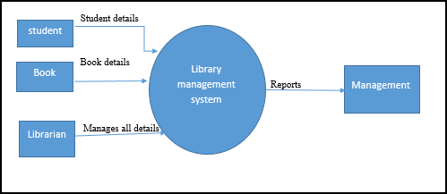

## Research instruments

In order to gain the insight of the current operation and gather virtual information so as to acknowledge the problems, l used the following methods:

1. Observation

2. Interview

### 1. Observations

* I chose this method of gathering information because it allowed me to see and have unequivocal information concerning the procedures used to accomplish different operations and the amount of time each procedure took to be completed.
* With the help of a guided tour throughout the sessions this proved to be a very successful information gathering tool as I managed to collect all necessary information.
* I observed that their system has poor data recovery techniques,
* The system has slow processing and does not provide security to information.
* Data duplication in files records was also noted.
* Students wait in long queues in order to borrow books due to slow system as a lot of paperwork is involved also as a result of only one librarian being employed.
* Searches for misfiled charts wasted time, location of records of students who had previously borrowed books took time to be found and at some point were not located at all hence a replacement of that record had to be made hence wasting resources.
* First-hand information was transited at the scene of action and information was gathered without disrupting normal proceedings of the day. However, this method proved to be subjective. Some procedures proved to be hardly discernible

### 2. Interview

* Interview was meant to produce an overview of the information flow and how that information is processed, handled and stored within the library. I prepared a script for questions to use my interview. In nutshell, interview provided the added advantage of offering a platform to follow through an idea or a question if it is not answered well. This interview also led to the exploration of other thoughts that came about during the interview. As the system developer, l was able to ask further questions as a follow up to an answer given which is likely as compared to observation. I managed to interview Mrs Mukapa the librarian.

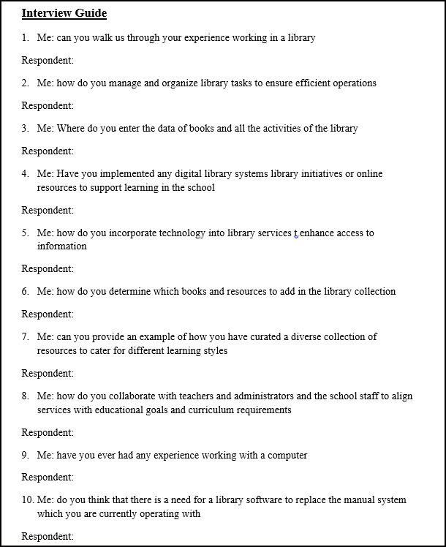

## Conclusion of Researches

* As a result of all the above research the information l managed to gather and attain concluded that the system was neither reliable nor was it benefiting the organization as it proved to only add more costs due to its inefficiency being the result of the manual based system that is currently in operation.
* Also service of the organization was being undermined because of these manual operations thus it was not operating at its full potential.
* Accessing records seems to be problematic thus need for addressing as it hinders most operations to be carried out efficiently and effectively thus time wastage is recognized.
* Also automation of this system will benefit the school library to a larger extent in the long run.
* System maintenance is made easier and cheaper also since the system developer would take care of all the needs of the system to ensure its smooth running.

## Description the Current System

* The current system is file based, meaning all current operations are performed manually and uses files meaning all current operations are performed manually and uses files to store their records for to maintain the day-day state of borrowing and returning of books
* library is open from 7:00 am to 4:00 pm, or sometimes there will be extension of time to filling upon the activity which is held inside the library.
* the student can borrow the book of their choice, they could take it inside or outside the library, they can use it.
* Their existing system is a manual processing of borrowing, returning and inventory of books. The follow process in their existing system.
* The Student and the teacher can borrow a book from the library.
* The Student will now search for the book/s that he/she wants to borrow
* He/she will now proceed to the librarian to confirm the books that He/she will borrow
* He/she now will fill out his/her details in the log book.
* When they about to return the borrowed book, the Student will put his/her signature in the log book to verify that they already returned the borrowed book
* the book should be returned after three days, if they fail to return the book, usually, Mrs Mukapa, tracks down the name of the student in the log book and then will warn the student to return the book immediately or else they will be punished.

## Problems with the current system

Based on the research made the current system has got the following problems:

• File lost

-files are is always lost because of human environment. Sometimes due to some human error there may be a loss of records.

• File damaged

Files, records and textbook damaged due to some accident like spilling of water, tearing of text books by students accidentally. Besides some natural disaster like floods or fires may also damage the files.

• Difficult to search record

-there is always a difficulty in searching of records and textbooks because the records are large in numbers

. • Space consuming

After the number of records become large the space for physical storage of file and records also increases if no computerized system is implemented.

• Cost consuming

As there is no computerized system then each record paper will be needed which will increase the cost for the management of library.

## Feasibility study

**Technical feasibility**

* Since the hardware and software’s are already available then this means that the system will operate efficiently. The system will run on currently available hardware and software e.g. word editors.

**Economic feasibility**

* The new system tends to be economically feasible as its benefits will ought to weigh costs in developing, installing and maintaining both hardware and software. It is financially feasibility since the students and the school already have laptops and they can use them to install the application program and same as for the schedule.

**Legal feasibility**

* The new system is legally feasible since it is within the laws of the country.

**Operational feasibility**

* The new system also tends to be operational feasible since the workers and the students are already trained and they are ICT compatible.

**Social feasibility**

* It is socially feasible because it is user friendly and acceptable since it does not lead to dismissal of other employees from work hence does not lead to unemployment

## Requirements specifications

### User requirements

|  |  |
| --- | --- |
| User | Access right |
| Administrator | Access all the records in the system and can change users and passwords |

**Design Requirements**

* System should have a colourful background.
* Error detection
* Attractive Output screen.
* View and read text books

**Input requirements**

* System should allow entering textbooks into the system.
* A security login system
* Search facility system – search for textbooks and videos
* Upload a new text book and notes and videos

**Processing requirements**

* Real time processing
* Back up of files and updates
* Error detection during inputting

**Output requirements**

* Interactive message boxes

### Software Requirements

Operating system-

Windows 7 or any other latter version is used as the operating system as it is stable and supports more features and is more user friendly

Text Editors- VS Code Editor

Development tools and Programming language- HTML is used to write the whole code and develop webpages with css, java script for styling work

***NB: make sure your computer contains an installed web browser.***

### Hardware Requirements

**Processor**

* Intel Pentium | Intel Core Generations (i3, i5, i7, i9)

**Inputs**

* Standard Mouse (LMB, RMB, Roller)
* Standard Keyboard (F1- F12)

**Storage**

* RAM 2GB
* Memory (HDD 500GB, SSD 20GB)

**Output**

* Monitor

## Aims

1. to develop a system of improved facilities
2. Designing a computerized library management system which would help evacuate the problem faced in manual library.
3. Implementing the system.
4. Evaluating and testing the performance of the system.

## Objectives

* Online book reading.
* A search column to search availability of books.
* An Admin login page where admin can add books, videos or page sources
* Open link for Learning Website
* Eliminate paperwork in the library
* Deign a user friendly graphical user interface which suit the users

# Section B

# Design

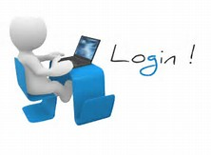

## Evaluation of the existing system

**The current system has the following strength:**

* It works independently of electricity since all its operation is done manually i.e. it is not affected by power failure or power cuts.
* No need for interval system update because it is manual.
* Less risks for users to suffer from diseases like eyesores caused by continuous use of computers

**However, it has the following detrimental effects**:

* Data duplication can be occurred by repeating the same thing over and over.
* Lack of security.
* Lack of storage- as the number of books increase the space in the library is becoming less every single year
* Too much paper wastage. Paper takes up a massive amount of room in the site.
* Poor Data Storage – All the data is stored in filling cabinets.
* Slow Retrieval of Data – The information is stored in different parts and takes a long time to

retrieve the data.

* Manual systems are also slow to operate.
* With manual systems staff spends a lot of their time on mechanical, clerical tasks rather than

liaising with library visitors.

* Librarian find it difficult to offer a wider range of new services with a manual library system.
* Time consuming – registering new books into the system is usually expensive

## Consideration of Alternatives

1. Upgrading the manual system
2. Buying a software package (Off the shelf-package).
3. Purchasing a generalized package
4. **Upgrading the manual system**

-The school can also decide to keep the manual system but make some changes that seek to address the weak areas of the existing manual system. They might incorporate the following changes to the manual system in a bid to make it more effective.

* The school could increase the number of employees so as to improve the delays in services delivery. Also an increase in the number of staff at the organization could prove to be helpful in increasing service delivery.
* Going through the daily transaction book at the end of each day to determine errors and mistakes as on that date.
* Adequate staff may be maintained so that updates are made at the very moment at the same time. Proper person for proper work should be made responsible so that a better efficiency could be achieved.
* The school can also build another library to increase the space for storage of books

**Advantages**

* Increasing the staff will ensure efficiency in carrying out tasks e.g. registering and arranging of books.
* Building another library will increase the space for storage of books

**Disadvantages**

* It is expensive to construct another library
* Increasing the staff will result in a lot of labour costs hence increasing school expensive expenses
* This solution does not save the problem of security issues as it may only worsen it because of the increase in number of people needing to access it.
* This would only worsen the problem of record duplication because when students come in for the second times they can be attended by a different member thus need to record their details again

**2. Purchasing generalized packages**

This would be the easiest method that includes purchasing a software package that was developed, tested and titrated by an external service provider. The software is purchased and installed in local marching containing a manual for instructions to the user package like Microsoft office with the following advantages:

**Advantages**

* Generalized systems are easier to use and implement as they come with a lot of supporting user documentation.
* Generalized systems are usually tried and tested such that there is no risk of data loss due to software failure.
* They provide easier and faster access to records and data.

**Disadvantages**

* Generalized packages will often contain a lot of features that are irrelevant to the school library system
* They might prove to be incompatible with the record keeping system used at the library, making them not user friendly.
* Original software is costly.
* The software contains some unwanted features and the software may not fit to the requirements specification.

## Justification of Method of Solution

* The introduction of a tailor made computerized system to handle all library activities

**Advantages**

* The system will address the specific need of the school library system for example; it can have search functions that allow users to search for records text book of their choice.
* The system will not have any features that are irrelevant to the school
* The system can be designed in such a way that it is user friendly.
* Take up less floor space for storage than even the most advanced of manual systems.
* With a tailor made computerized system there is no need to change the organization structure, for example employing more staff members which is costly.
* A new system can be equipped with tailor made security features that give data access rights and levels that would be hard to specify on a generalized application package.
* It is fast since processes are easily done by the computer and errors are reduced
* The information will be stored in a computer for a long period of time without any data loss.
* It is a fast way of entering and retrieving information since text book and videos will be easily identified.

.

**Disadvantages**

* It requires enough maintenance and the cost of buying the hardware like the monitor are too high.
* A tailor made system might take time to develop.
* If it is poorly designed, you might lose some data due to software failure.
* May not meet the organization specification or may not comply with the organization resources.

The system can be hacked or the data can be corrupted

## Input Designs

* This part contains the structure of the input of data in the proposed system.

## Data capture forms

* These parts require the user to enter details in order to register a new user or book into the system

**\*\*\*\*\***

## Screen Layouts

1. login

-Prompts the user to enter the admin ID and password to give the right privileges to the system.

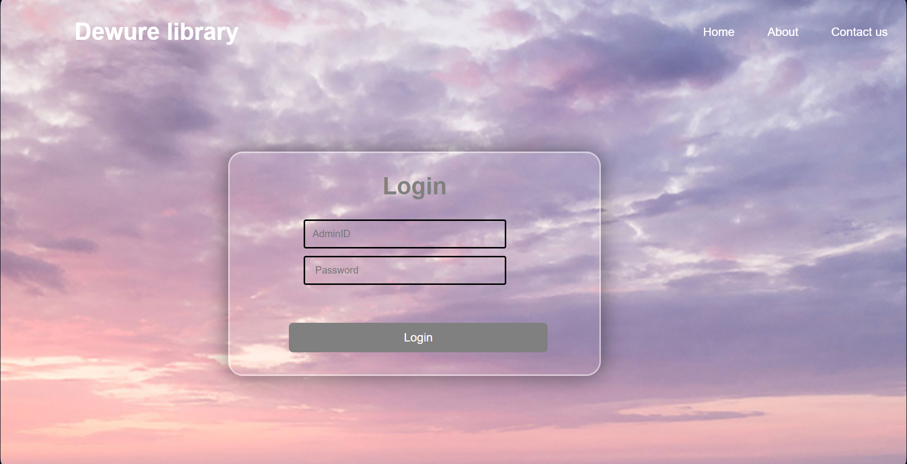

1. e-books

-this is where the user add / uploads a new book into the system

-there is choose file button allows the user to select the pdf they want to upload from the folders on their local machine

-the upload button uploads the selected file onto the webpage and the delete button deletes the file

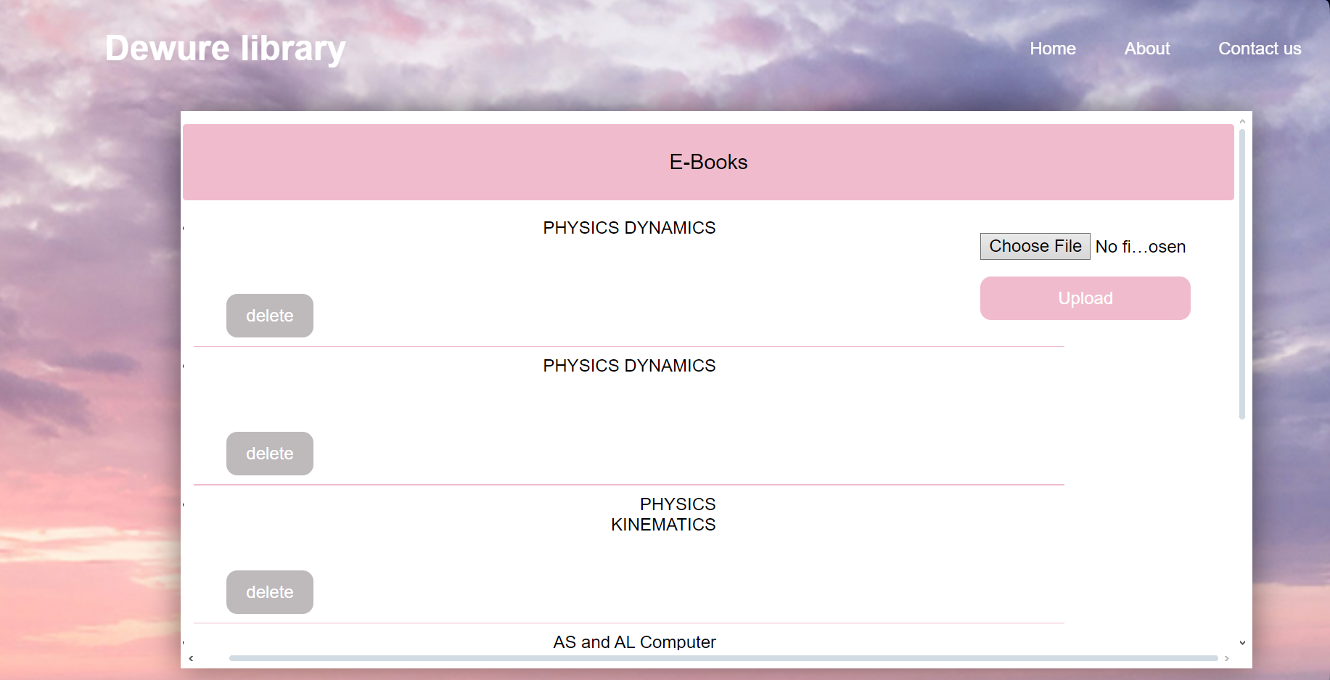

1. video

-this is where the user uploads a new video

-The user will have the option of choosing from any of the command above. For instance, the delete button will enable the user to delete the video. The upload button will enable uploading of a new video from the user’s local machine.

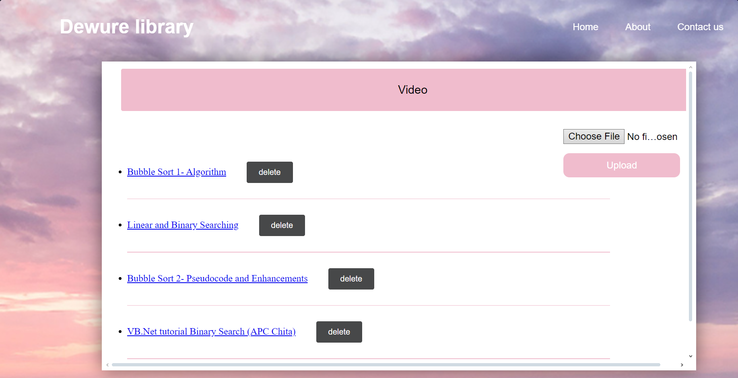

- Clicking the description allow for the user to play the video as shown below

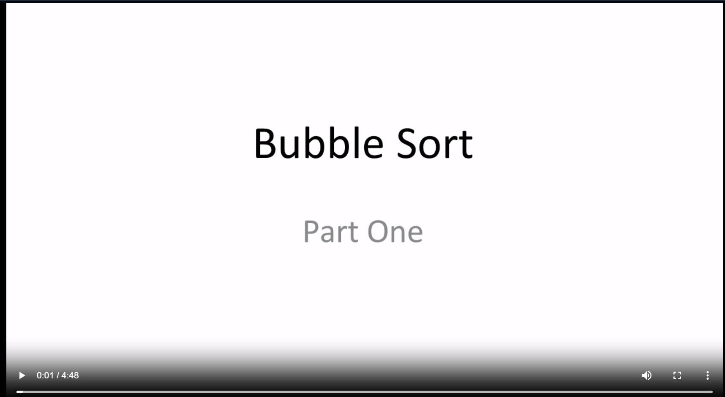

## Data structures

1. The class diagram for the library system



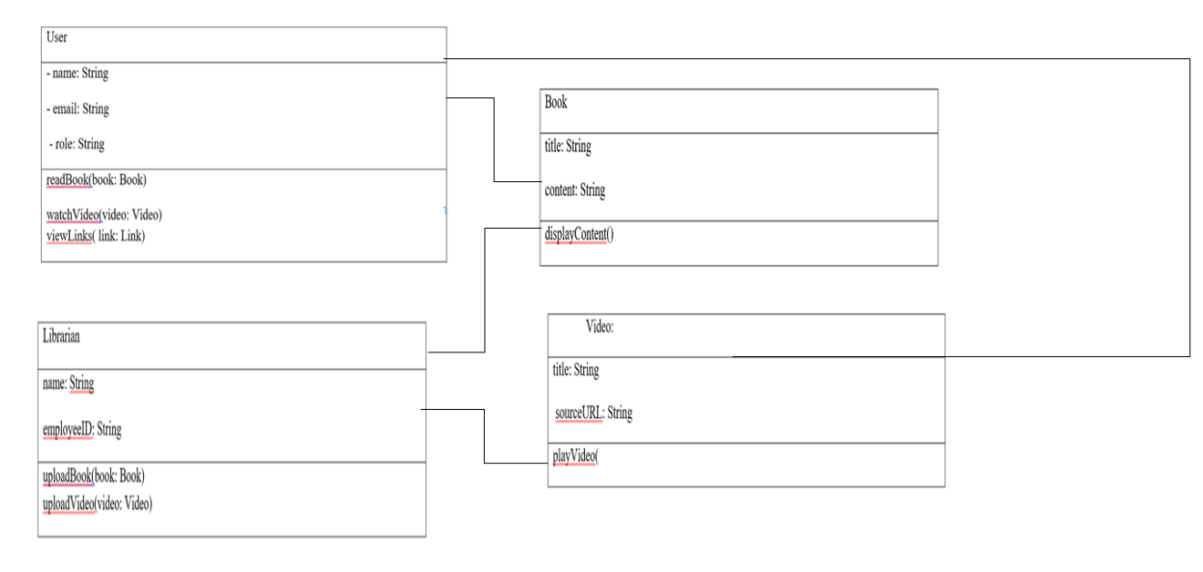

1. use case diagram

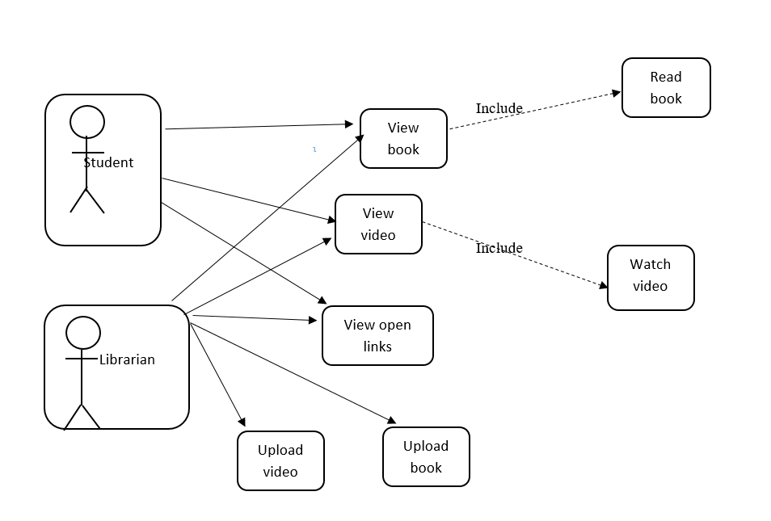

1. Sequence diagram

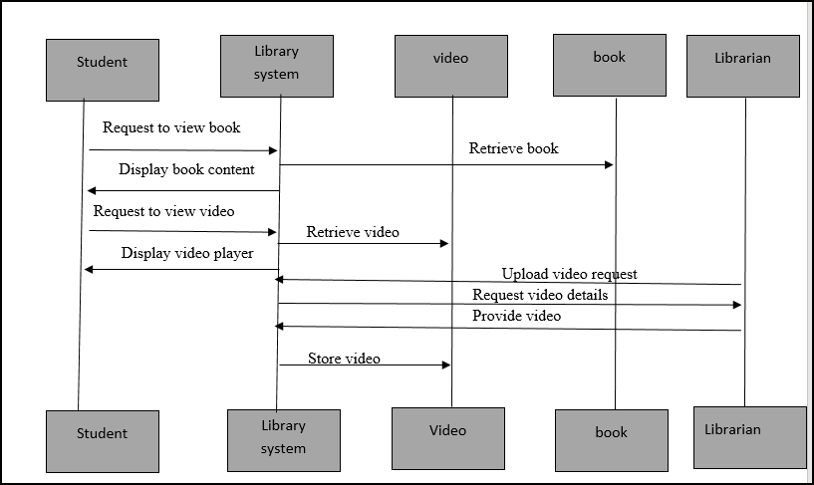

## Overall plan

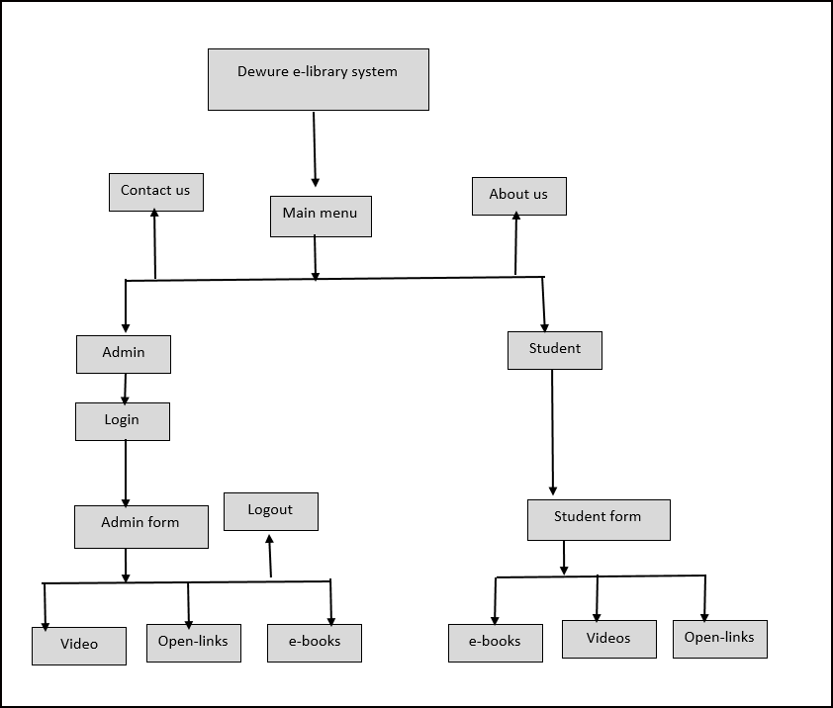

## Output design

1. **Output Design of a pdf/ textbook**

* **The design might differ a little depending on the web browser being used**

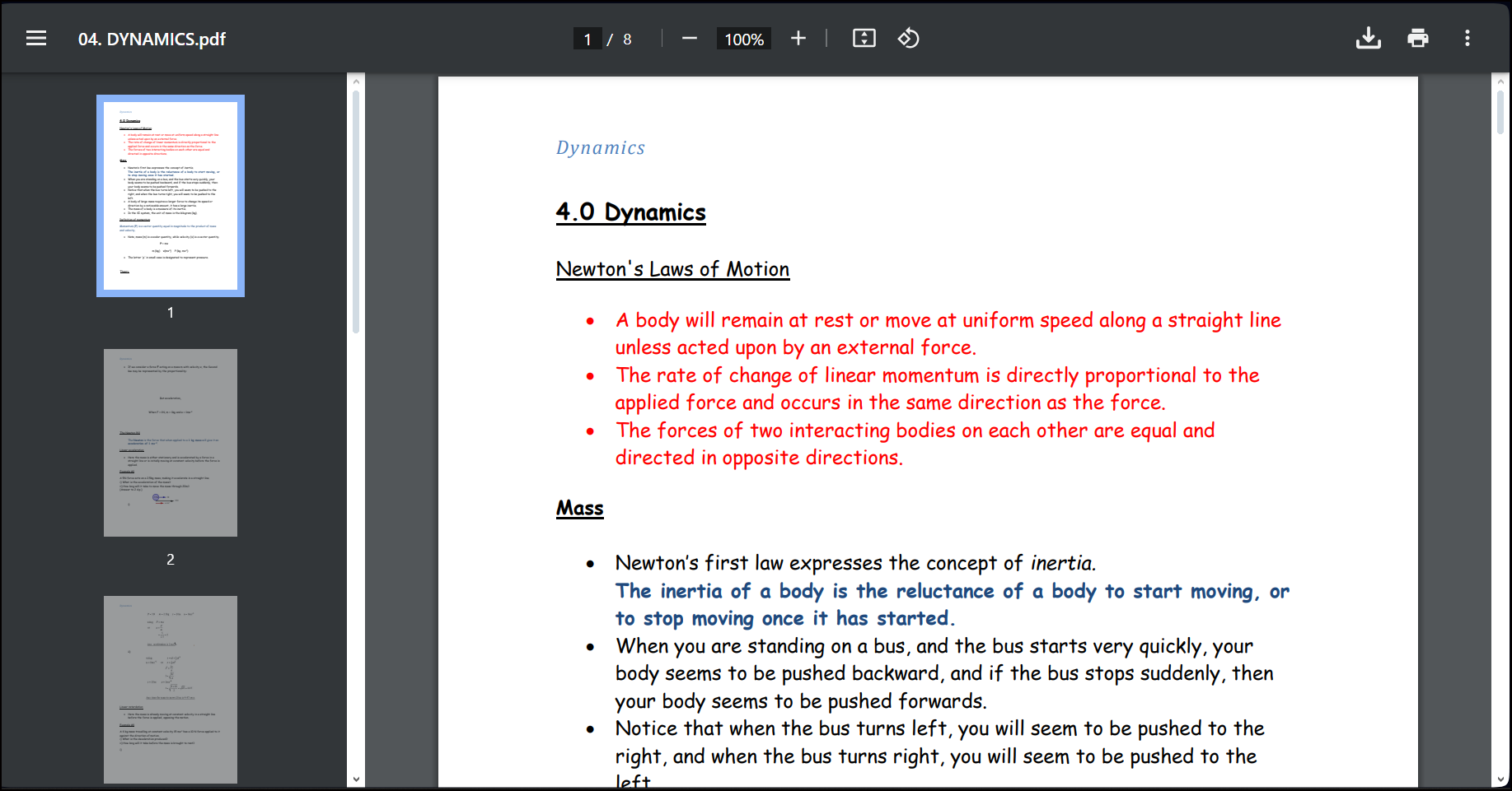

1. **video**

* **There are options for increasing the volume, full screen playing, etc.**

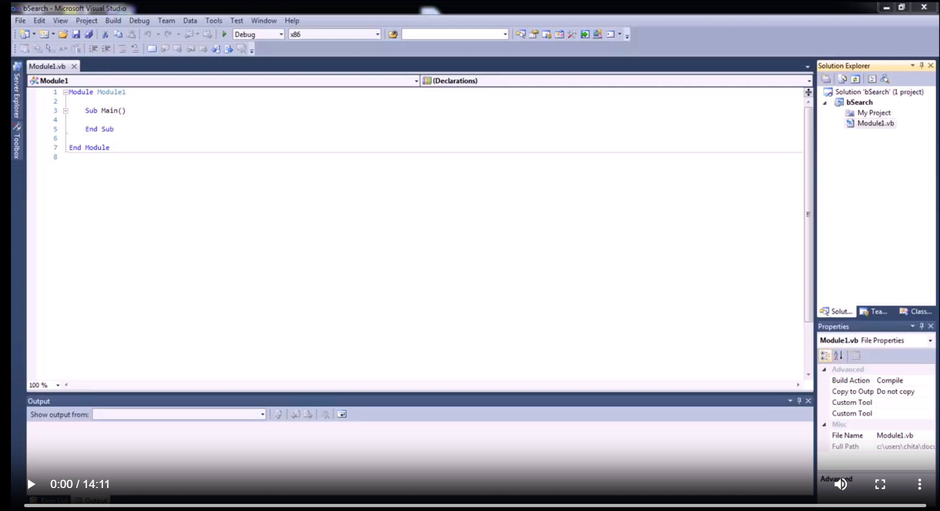

## Test plan

* In this section I am to undertake a test of the system to verify if the results are as expected, and that the system’s performance moves in line with the requests of the end-user.

For my test plan, I will be using to use the following strategy:

### Black Box Testing

* Black box testing is when selected test data is imputed and the actual output is compared with the expected output, without considering the way in which the program works.

**Modules under testing: Users**

|  |  |  |  |
| --- | --- | --- | --- |
| Module | Purpose | Test data | Expected results |
| View book | To see if the users can view and interact with books | Clicking the link of the book | The book opens on a new tab |
| Upload video | To see if the user can upload a new video onto the website | Selecting the video to upload | A message indicating a message of a successful upload |
| Deletion of a video /pdf | Checking if the system can delete irrelevant videos and pdfs | Selection of a video/pdf to delete | A message indicating that the deletion of the file was a success |

# Section c

# Software Development

## Technical documentation

**Modules and Algorithm**

**Searching for a book**

It allows the user to search for books on the website and to search for records needed to be processed by the user

**Start**

**Input** search query

**If** the search criteria match a book in

the file **Then** =

Display the book

**Else**

Display nothing

**End if**

**Stop**

**Program flowchart**

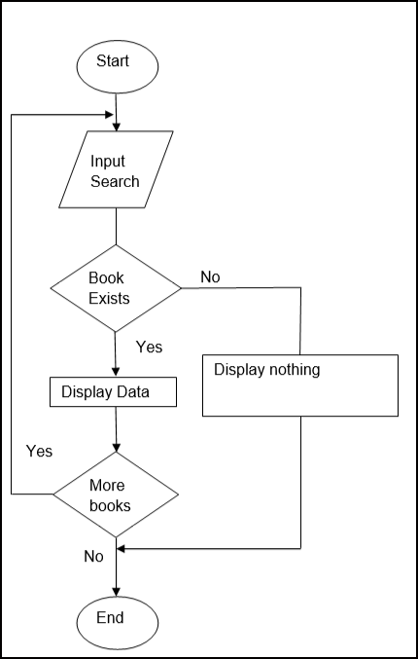

**Deleting a book/ video**

**Algorithm**

**Start**

**Select an option**

**If** delete is chosen, **Then**

Remove book/video

**End if**

**End**

**Program flowchart**

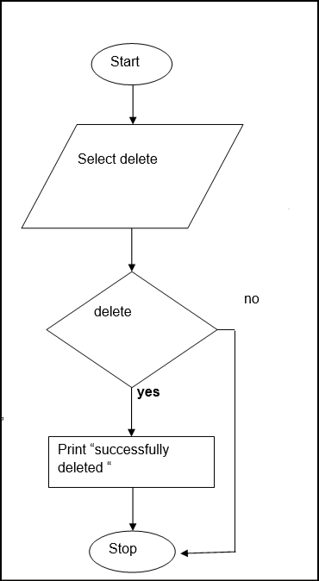

**Uploading a book**

**-allows the user to upload anew book on the webpage**

Algorithm

**Start**

**Input** book

**If** book upload is successful, **then**

**Output**

upload successful

**End if**

**End**

**Flowchart**

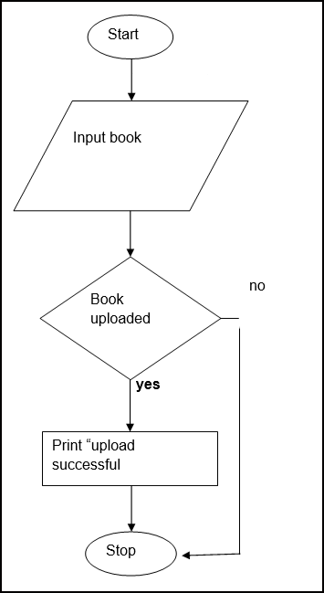

**Code listings**

User documentation

# Section D

# Testing and evaluation

## User testing

* User testing is a type of system **testing** done from an end-**user's** perspective to determine if the **system** is easily usable.

**Module under testing: e-book**

Uploading new book

|  |  |  |  |
| --- | --- | --- | --- |
| File | Test data | Validation | Expected results |
| Normal data | Selecting one book to upload | At least one book should be selected to upload | Accepted |
| Extreme data | Selecting more than one book to upload | At least one book should be selected to upload | Accepted |
| Abnormal data | Selecting nothing | At least on book should be selected | Rejected |

Normal data

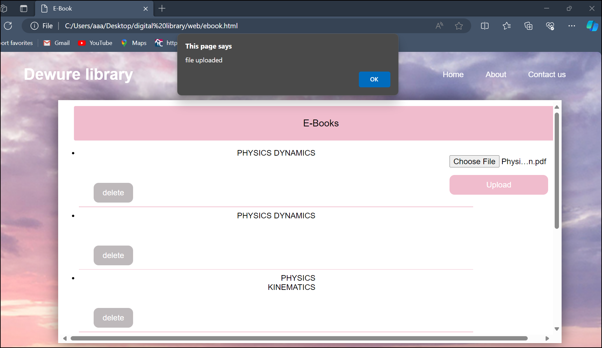

Extreme data



Abnormal data

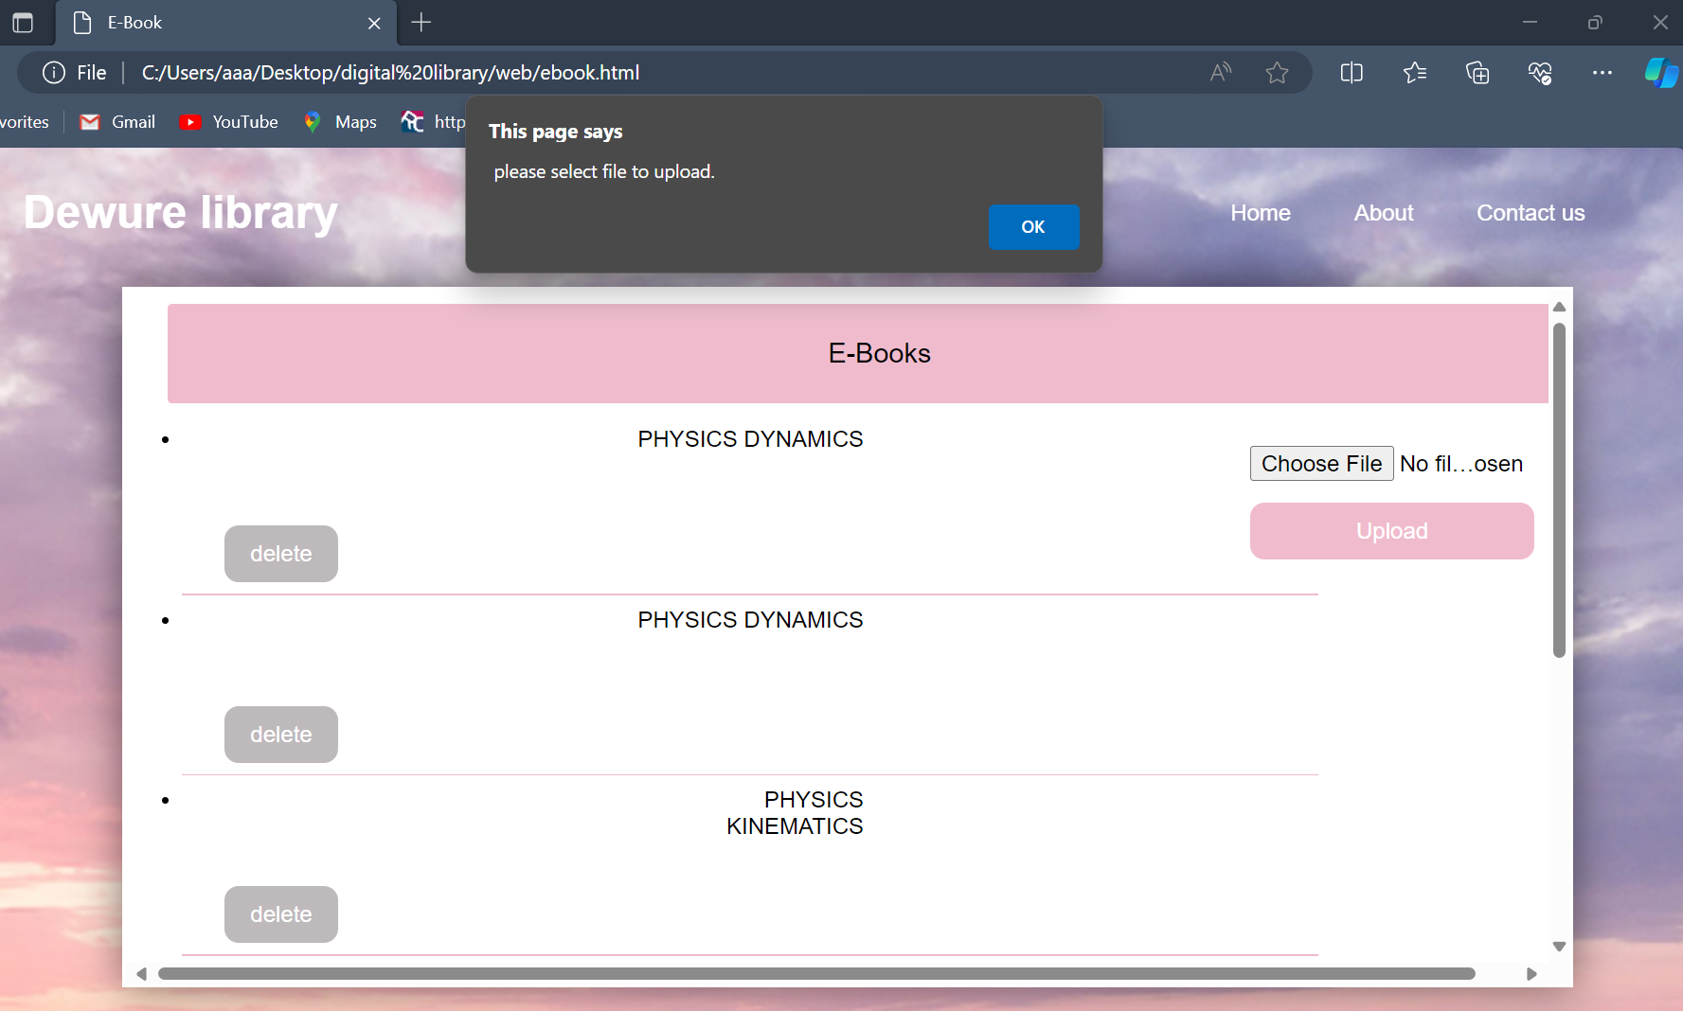

## Evaluations of the system

Achievement

It is a great improvement over the manual system. The computerization of the system has speed up the process. In the current system, the front office managing is very slow. The e- library system was thoroughly checked and tested with dummy data and thus is found to be very reliable. The software takes care of all the requirements of an average library

* It provides the facility for searching the books and videos available in the system
* The system is able to delete unwanted videos and books
* It can also upload videos and books
* It ensures security since no unauthorised user can modify any data in the system i.e.it has a login page for the admin to login in order to modify any data
* The system is able to display books and play videos
* The system is able to open links

Weakness

* When an error occurs the system is just able to detect that an error has occurred by showing the message on the message box and the system is not able to the user on how to correct the error.
* The size of the database increases day-by-day, increasing the load on the database back up and data maintenance activity

Opportunities for future developments

* To use online Registration students
* To add another module whereby the system will be able to tell the user on how to correct the error in the event that an error has occurred.
* To encrypt the password and put password on each and every interface that you try to open.
* To add another module that will always be able to calculate number books and videos available in the system
* To add a book with an image of a cover page